

**DEPARTMENT OF MECHATRONICS ENGINEERING**

**ROBOTICS LAB MANUAL**

M. Tech (Industrial Automation and Robotics)

|  |  |  |
| --- | --- | --- |
| Prepared By | Dr. Asha C S Dr. Pooja Nag | Original Manual |
| Approved By | Dr. D V Kamath  (Head - Department of Mechatronics) |  |



**DEPARTMENT OF MECHATRONICS ENGINEERING**

**ROBOTICS LAB MANUAL**

M Tech (Industrial Automation and Robotics)

**NAME: REG NO: ROLL NO:**

# VISION OF THE MECHATRONICS ENGINERING DEPARTMENT

Excellence in Mechatronics Education through Innovation and Team Work.

# MISSION OF THE MECHATRONICS ENGINEERING DEPARTMENT

Educate students professionally to face societal challenges by providing a healthy learning environment grounded well in the principles of Mechatronics engineering, promoting creativity, and nurturing teamwork.

# NBA PROGRAM EDUCATIONAL OUTCOMES OF THE MECHATRONICS ENGINEERING DEPARTMENT (PEOs)

The graduates**:**

**PEO1:** Are expected to apply analytical skills and modelling methodologies to recognize, analyze, synthesize and implement operational solutions to engineering problems, product design and development, and manufacturing.

**PEO2:** Will be able to work in national and international companies as engineers who can contribute to research and development and solve technical problems by taking an initiative to develop and execute projects and collaborate with others in a team.

**PEO3:** Shall be capable of pursuing higher education in globally reputed universities by conducting original research in related disciplines or interdisciplinary topics, ultimately contributing to the scientific community with novel research findings.

**PEO4:** Are envisioned to become technology leaders by starting high – tech companies based on social demands and national needs.

**PEO5:** Shall develop flexibility to unlearn and relearn by being in pursuit of research and development, evolving technologies and changing societal needs thus keeping themselves professionally relevant.

# NBA PROGRAM OUTCOMES (PO):

The POs are exemplars of the attributes expected of a graduate of an accredited programme:

**PO1-** Apply the knowledge of mathematics, science, engineering fundamentals, and an engineering specialization to the solution of complex engineering problems.

**PO2-** Identify, formulate, research literature, and analyze complex engineering problems reaching substantiated conclusions using first principles of mathematics, natural sciences, and engineering sciences.

**PO3-** Design solutions for complex engineering problems and design system components or processes that meet t h e specified needs with appropriate consideration for the public health and safety, and the cultural, societal, and environmental considerations.

**PO4-** Use research-based knowledge and research methods including design of experiments, analysis and interpretation of data, and synthesis of the information to provide valid conclusions.

**PO5-** Create, select, and apply appropriate techniques, resources, and modern engineering and IT tools including prediction and modelling to complex engineering activities with an understanding of the limitations.

**PO6-** Apply reasoning informed by the contextual knowledge to assess societal, health, safety, legal, and cultural issues and the consequent responsibilities relevant to the professional engineering practice.

**PO7-** Understand the impact of the professional engineering solutions in societal and environmental contexts, and demonstrate the knowledge of, and need for sustainable development.

**PO8-** Apply ethical principles and commit to professional ethics and responsibilities and norms of the engineering practice.

**PO9-** Function effectively as an individual, and as a member or leader in diverse teams, and in multidisciplinary settings.

**PO10-** Communicate effectively on complex engineering activities with the engineering community and with society at large, such as, being able to comprehend and write effective reports and design documentation, make effective presentations, and give and receive clear instructions.

**PO11-** Demonstrate knowledge and understanding of t h e engineering and management principles and apply these to one’s own work, as a member and leader in a team, to manage projects and in multidisciplinary environments.

**PO12-** Recognize the need for, and have the preparation and ability to engage in independent and life-long learning in the broadest context of technological change.

# NBA PROGRAM SPECIFIC OUTCOMES OF THE MECHATRONICS ENGINEERING DEPARTMENT (PSO’s)

At the end of the course the student will be able to:

**PSO1:** Apply the knowledge of sensors, drives, actuators, controls, mechanical design and modern software tools to integrate a system for performing specified tasks.

**PSO2:** Articulate designs, modelling, analysis, and testing of Mechatronics products, systems and controllers using appropriate technology and software tools.

**PSO3**: Able to interface devices and elements to a central system having the capability of real-time data sharing, storage, retrieval, analysis, and decision making with global connectivity features for visibility and intervention.

# IET LEARNING OUTCOMES (LO):

|  |  |  |  |
| --- | --- | --- | --- |
| **PLO** | **Competency (Area of learning/Graduate Attributes)** | **LO** | **LO Statement** |
| Science and Mathematics | Science, Mathematics and engineering principles | M1. | Apply a comprehensive knowledge of mathematics, statistics, natural science and engineering principles to the solution of complex problems. Much of the knowledge will be at the forefront of the particular subject of study and informed by a critical awareness of new developments and the wider context of engineering |
| Engineering Analysis | Problem Analysis | M2. | Formulate and analyse complex problems to reach substantiated conclusions. This will involve evaluating available data using first principles of mathematics, statistics, natural science and engineering principles, and using engineering judgment to work with information that may be uncertain or incomplete, discussing the limitations of the techniques employed |
| Analytical Tools and Techniques | M3. | Select and apply appropriate computational and analytical techniques to model complex problems, discussing the limitations of the techniques employed |
| Technical Literature | M4. | Select and critically evaluate technical literature and other sources of information to solve complex problems |
| Design and Innovation | Design | M5. | Design solutions for complex problems that evidence some originality and meet a combination of societal, user, business and customer needs as appropriate. This will involve consideration of applicable health & safety, diversity, inclusion, cultural, societal, environmental and commercial matters, codes of practice and industry standards |
| Intergrated/Systems Approach | M6. | Learning outcome achieved at previous level of study |

|  |  |  |  |
| --- | --- | --- | --- |
| The Engineer and Society | Sustainability | M7. | Evaluate the environmental and societal impact of solutions to complex problems (to include the entire life-cycle of a product or process) and minimise adverse impacts |
| Ethics | M8. | Learning outcome achieved at previous level of study |
| Risk | M9. | Learning outcome achieved at previous level of study |
| Seccurity | M10. | Learning outcome achieved at previous level of study |
| Equality, Diversity and Inclusion | M11. | Learning outcome achieved at previous level of study |
| Engineering Practice | Practical and Workshop Skills | M12. | Learning outcome achieved at previous level of study |
| Materials, Equipment, Technologies and Processes | M13. | Learning outcome achieved at previous level of study |
| Quality Management | M14. | Learning outcome achieved at previous level of study |
| Engineering and Project Management | M15. | Learning outcome achieved at previous level of study |
| Teamwork | M16. | Function effectively as an individual, and as a member or leader of a team.  Evaluate effectiveness of own and team performance |
| Communication | M17. | Communicate effectively on complex engineering matters with technical and non-technical audiences, evaluating the effectiveness of the methods used |
| Lifelong Learning | M18. | Learning outcome achieved at previous level of study |

**COURSE LEARNING OUTCOMES**

**CO1/CLO1: Identify** the real-world scenarios where robotics and autonomous systems might be applied using the ROS2 package.

**CO2/CLO2**: **Develop** different robotic models using simulation tools and apply kinematic and dynamic models of robots for moving them.

**CO3/CLO3: Use** sensing and actuation systems applied to robotic systems, and the importance of using multiple sensors in robotic and autonomous systems in simulation and real mobile robots/industrial robots for automation.

**CO4/CLO4**: **Develop** algorithms for mobile robot navigation, as well as control of multi- axis manipulators.

**CO5/CLO5**: **Develop** an application involving functional safety, health, ethical, management, legal, society, and environment as a team member or leader.

**CO6/CLO6: Communicate** the results to peers through report writing and oral presentation.

**CO7/CLO7**: **Identify** the use of various industry standards, refer literature, blogs, books while implementing the mini project.

# GENERAL GUIDELINES OF PROFESSIONAL CONDUCT:

* Be in the Lab 10 min prior to the schedule. Latecomers will have a penalty of some marks, and an apology letter to be written and submitted.
* Always conduct yourself in a responsible manner in the laboratory.
* Follow all written and verbal instructions carefully. If you do not understand a direction or part of a procedure, ask the faculty before proceeding with the activity.
* Perform only those experiments authorized by your faculty. Carefully follow all instructions, both written and oral. Unauthorized experiments are not allowed.
* Observe good housekeeping practices. Work areas should be always kept clean and tidy.
* Be alert and always proceed with caution in the laboratory. Notify the faculty immediately of any unsafe conditions you observe.
* Labels and equipment instructions must be read carefully before use. Set up and use the equipment as directed by your faculty.
* Experiments must be personally always monitored. Do not wander around the room, distract other students, startle other students, or interfere with the laboratory experiments of others.
* Report any accident (breakage, short circuit, etc.) or injury (cut, burn, etc.) to the teacher immediately, no matter how trivial it seems. Do not panic

# SAFETY INSTRUCTIONS

|  |
| --- |
| Don’t enter the fenced area of the robot while the robot is idle or working. |
| Wear safety shoes while working in the Laboratory. |
| Don’t operate /program the Robot at the full speed mode. |
| No unauthorized experiments/programs should be performed. |
| Do not eat or drink in the laboratory. |
| Before beginning to work in the laboratory you should be familiar with the standard operating procedure of each equipment/component you may be using. |
| In case of an accident or any unexpected event like a short circuit, burning of components,  sparks in or around the workplace, immediately inform the faculty or lab instructor. |

**EVACUATION ROUTE PLAN**

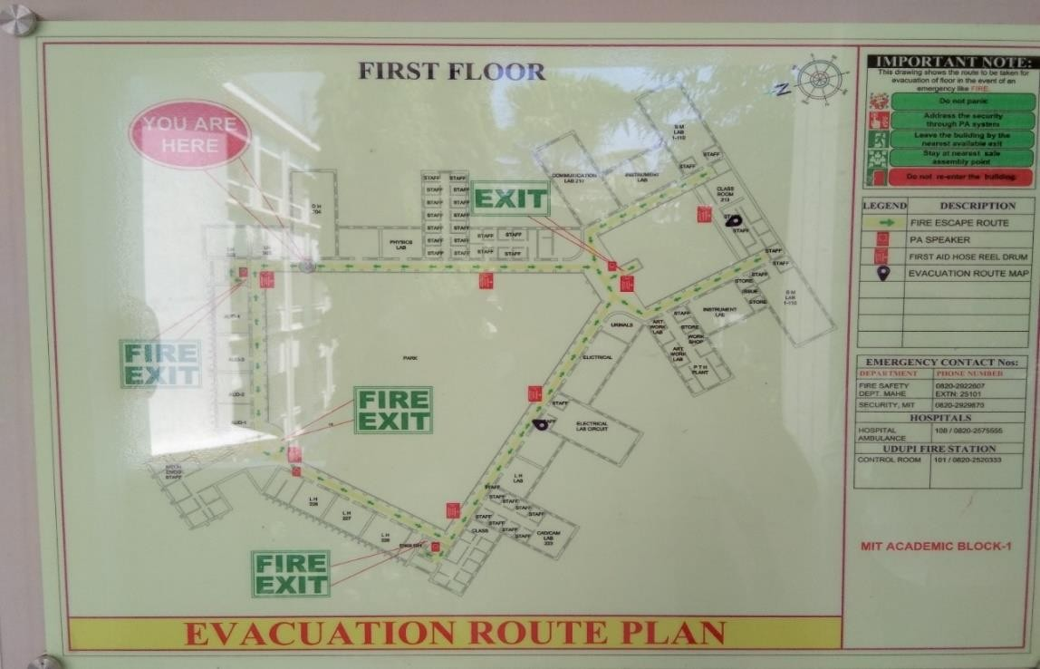

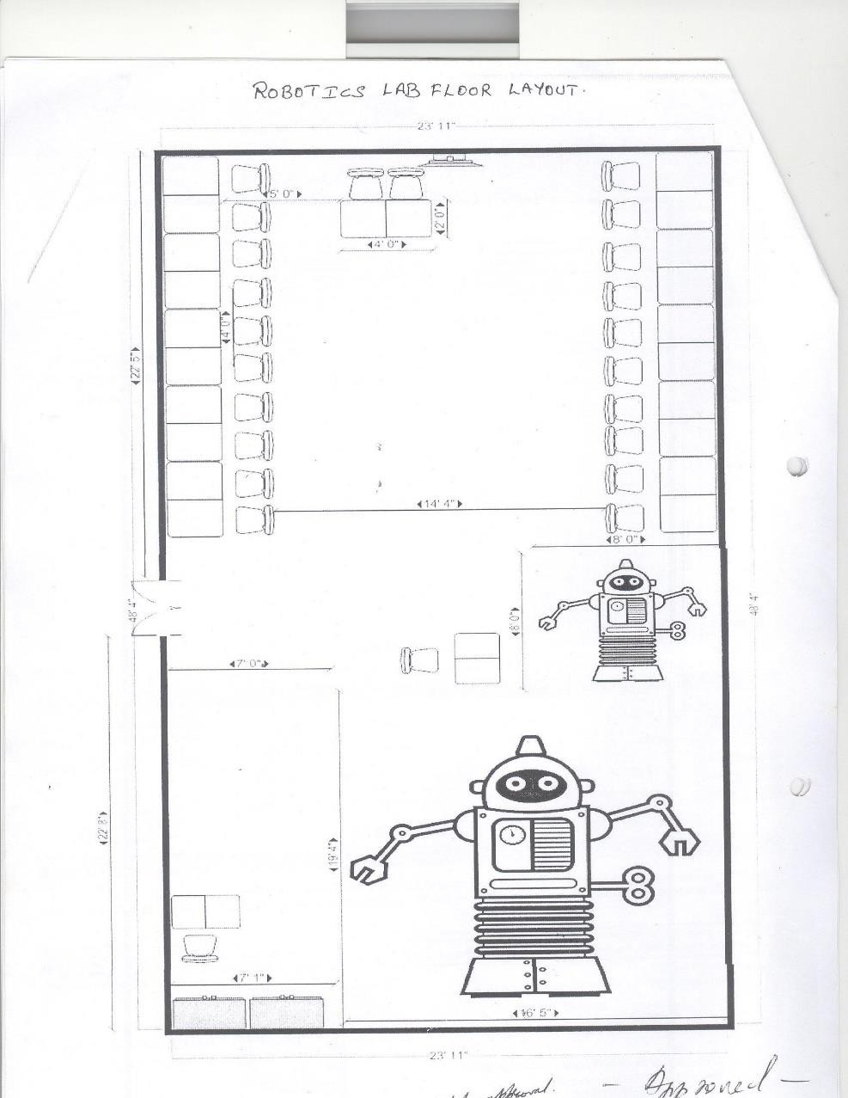**FLOOR PLAN/ELECTRICAL LAYOUT**

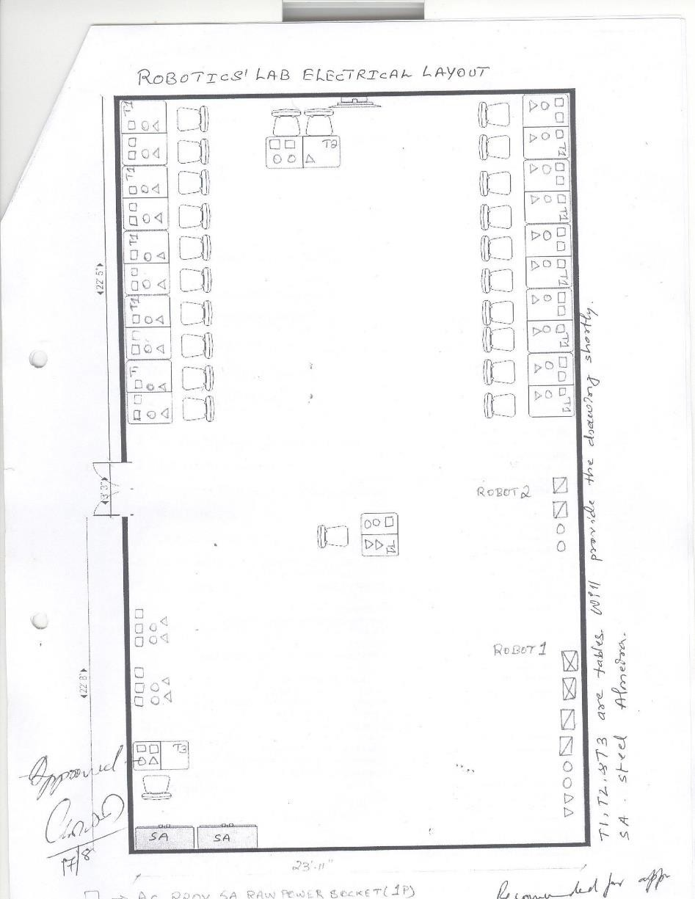**FLOOR PLAN/ELECTRICAL LAYOUT**

**CIVIL LAYOUT**

**COVID SAFETY NORMS**



1. Wearing masks, gloves, and shoes is mandatory for all labs.
2. Each student must sit/stand at the Yellow marked place only, both inside and outside the lab.
3. Maintain social distance from each other.
4. Cover your mouth with a tissue/handkerchief (or sleeve if there are no tissues available) when you cough or sneeze and wash your hands afterward.
5. Throw away used tissues in a bin and wash hands after contact with coughing/sneezing.
6. Enter the lab only after using the hand sanitizer which is kept outside each lab. Wash hands with soap and water after leaving the lab even when the hands are visibly clean.
7. Signs & symptoms of cough, fever, or difficulty in breathing should be reported to the lab faculty immediately.

# LAB UNIQUE FEATURES

IRB 2600 Robot system (ABB) LIDAR-laser range scanner Depth Sensors

Turtle bot

UR5 Industrial Robot

# KEY FEATURES AND EVENTS

State-of-the-art industrial robots.

Hands-on training with COBOT and TURTLEBOT

Industry-standard Robot Operating System based programming Mini project presentation

# LIST OF EXPERIMENTS

|  |  |  |  |  |  |
| --- | --- | --- | --- | --- | --- |
| **Sl.**  **No.** | **TITLE OF EXPERIMENT** | **DATE** | **PAGE NO.** | **FACULTY SIGN** | **MARKS** |
| **1.** | Introduction to Linux and Python programming |  |  |  |  |
| **2.** | Introduction to ROS2, Publisher and Subscriber |  |  |  |  |
| **3.** | ROS2- Services and Actions |  |  |  |  |
| **4.** | Turtlesim programming in ROS2 |  |  |  |  |
| **5.** | URDF for mobile robot and manipulator |  |  |  |  |
| **6.** | Turtlebot Programming with ROS2 |  |  |  |  |
| **7.** | Sensors/Vision sensor integration with ROS2 |  |  |  |  |
| **8.** | i. IRB2600 jogging and tracing a shape ii.IRB2600 online programming for Pick and place operation |  |  |  |  |
| **9.** | Introduction to COBOT:   1. Pick and place with sensor input 2. Loop based pick and place operation |  |  |  |  |
| **10.** | Mini-Project   1. Model a Mobile robot using 3D printer 2. Model in Gazebo environment using URDF 3. Develop a solution for robotic vision application using OpenCV and ROS 4. COBOT application with vision/ROS 5. Any other |  |  |  |  |

**Self-Study Material: Robotic Safety Industry Standards**

Aim:

* To know safety, risk assessment, ethical, quality management, moral issues in the industry environment.
* To know various industry standards applicable to robotic engineer

Source: {https://blog.isa.org/new-industrial-standards-robotic-safety} Books:

* Functional safety: safety instrumented systems for the process industry sector
* Safety Instrumented Systems: Design, Analysis, and Justification,

There have been significant changes in industrial safety standards for robotics. Safety managers, plant managers, and others need to keep pace with the latest codes and regulations. According to the U.S. Occupational Safety and Health Administration (OSHA), “machine guarding” that pertains to machines’ general requirements and general industry (29 CFR 1910.212) consistently falls in the top ten most frequently cited OSHA standards violated in any given year.

When combined with newly introduced safety regulations, it is easy to understand why this commonly misunderstood topic is more confusing than ever. The multitude of robotic applications and the growth of robot use and automation in all industries only worsens the problem.

Conducting a thorough risk assessment is the best way to maintain a safe work environment, especially when adding new automated processes. Thanks to the Robotic Industries Association (RIA) R15.06-2013 standard, proper risk assessments are no longer just a best practice; they are mandatory.

RIA 15.06-2013 harmonizes international and U.S. standards

This standard references ISO 10218-1 & 2, which addresses robots, robot systems, and integration. The RIA 15.06-2013 was written to be compliant with international standards already in place in Europe, making life easier for manufacturers and end users. This standard requires better hazard identification related not only to robotic motion, but also to the task being performed. Additionally,

it requires validation and verification of the safety systems employed and requires designs that incorporate protective measures for the robot cell and the operator.

Some of the biggest changes in the RIA 15.06 industrial robot standard have to do with safety- rated motion and allowing advanced programmable safety devices to be used. What this means is software will now be allowed “safety-rated” control of various aspects of the robot’s function, limiting the area in which the robot operates and the speed of robot motion. This is a departure from older standards in which programmable safety controls were not allowed. In addition, as part of this standard, risk assessments are now required. Many professionals responsible for plant safety have been conducting risk assessments to increase safety as a matter of practice. These regulations mandate risk assessments be conducted.

The basics of machine guarding risk assessment

Understanding and assessing these risks—and ensuring compliance—is not a simple task. The first step for facility/safety professionals is to identify and understand all applicable codes and regulations for their facility and operation. Next, they should examine the prevailing machine guarding choices for those applications to validate their safety system and its components. Although many guarding methods and products are available, not all can be applied universally. Every machine guarding application has a set of unique challenges and associated risk.

The choices a facility manager makes for one application might not be the same, or appropriate, for the next. In most cases, safety-conscious managers would not guard an industrial robot the same way they would guard other equipment, because the risk associated with each differs greatly. Risk may even vary between similar operations, depending upon employee exposure and other factors.

Determining risk

When performing a proper risk assessment, point-of-operation guarding is the most involved aspect. It is easy to place perimeter guarding around the entire process. However, in most situations a machine operator needs to interact with the process by loading or unloading materials (such as metals to be welded) and “running” the machine. This point-of-operation is where things get tricky. Many details must be considered when it comes to this area, including the layout or design of the process and the limits of the system.

Also, facilities must properly identify all associated hazards and devise methods for hazard elimination and risk reduction. Once the severity of the potential hazard has been determined, the

frequency or duration of exposure and the possibility of eliminating or limiting exposure can help safety managers choose the proper machine guarding device. Also, using the distance formula identified in OSHA guidelines can help in this selection. Per this formula, the safeguarding device has a prescribed location based on a number of factors, including secondary hazards that might harm a machine operator.

Limiting hazard exposure

Light curtains, laser scanners, and other presence-sensing devices are a commonly used and widely accepted method of machine guarding in manufacturing facilities from Tier 1 automotive to small machine shops and fabrication facilities. With presence-sensing, the automated process ceases once the safety device’s infrared beam is tripped. In many instances these devices provide acceptable safety.

However, they are not always the best choice in all applications, especially after a risk assessment is performed. Curtains may be the right choice in some applications. However, fast-acting automated barrier doors or roll-up curtains may be better choices because they can eliminate exposure to both the dangerous movement of the machine and the secondary hazards produced by the process, such as smoke, flash, splash, mist, and flying debris. This further diminishes the potential risk and the severity of exposure.

Coupled with safety interlocks (up to PLe per EN ISO 13849-1 when integrated properly), automated barrier doors and roll-up curtains offer an increased level of protection for point-of- operation guarding. They restrict access to the process and contain secondary hazards of automated welding operations by placing a barrier between machine operators and machine movement. These types of guards are an ideal alternative to light curtains and other presence-sensing devices in many situations.

A fast-acting automated barrier door or roll-up curtain eliminates exposure to dangerous movement machines and hazards produced by the process, such as smoke, flash, splash, mist, and flying debris.

From EN 954-1 to ISO 13849-1 and EN 62061

One of the biggest regulatory paradigm shifts occurred with the move from EN 954-1 to ISO 13849-1 and EN 62061. Although approval of this harmonized standard was a hotly contested fight, it is now here to stay. Fortunately for those in charge of safety, best practices and market- ready solutions already exist. ISO 13849-1, when broken down to the basics, provides a clearly defined set of rules to follow when designing the safety system as applied to industrial machine control systems. Officially defined as “safety of machinery, safety-related parts of control systems, general principles for design,” this regulatory shift was made necessary by increasingly complex manufacturing processes using robotic and automated technology.

Safety control systems and methodologies were forced to keep pace. The ISO 13849-1 standard is more quantitative than EN 954-1. It applies common sense and forces facility managers to validate their safety systems, whereas EN 954-1 was conceptual and only required facilities to apply safety devices (controls) properly, specifying non-programmable, out-of-date technology. Let’s face it, our increasingly complex manufacturing processes require more complex systems to monitor their safe operation and keep machine operators safe.

Automated processes, robotics, and even time-tested processes all require considerable attention to ensure those processes can proceed both efficiently and safely. EN ISO 13849-1 is ultimately making a much safer manufacturing environment, because it accounts for the regulatory gaps in the older standards. Because every robotic system is different and has its own set of guidelines, it is important to realize what they are before implementation.

Know specifications such as space and cycles. Integrators of new robotic systems will be required to perform these risk assessments in an attempt to identify potential dangers and ways to limit and eliminate them. RIA 15.06 is similar to ISO 13849-1 in that it has a quantitative approach to hazard identification. A functional safety requirement of D (performance level “d”) will be required of all robotic systems, as well as structure category 3 (dual channel), unless a risk assessment determines otherwise. PL safety and category ratings will offer a much more measurably reliant way to gauge safety.

The new standards in safety

For regulations such as RIA 15.06 and EN ISO 13849-1, it is important to keep up with the latest and greatest safety technologies available to match the right product to the right process. Consider not only potential machine hazards, but also the task being performed. Advances in design and

available technology make automated barrier doors ideal for guarding the machine and protecting operators, ultimately increasing productivity and the level of safety for years to come.

Creating a smaller manufacturing cell

Due to the nature of a properly interlocked automated barrier door, certain aspects of OSHA’s safety distance formula become moot, because there is no depth penetration factor. The safeguard can be placed much closer to the hazardous area, and there is less space dedicated to a “safety zone,” which reduces the manufacturing cell’s footprint. This space savings is a huge benefit in most facilities.

The smaller safety zone may also help to increase productivity and create a better ergonomic situation for the machine operator by limiting required motion. Eliminating accidental entry into the cell is another benefit of interlocked automated barrier doors. Because their safeguarding can be seen (unlike the invisible infrared beams of presence-sensing devices), they greatly reduce the opportunity for accidental work stoppage. The physical separation is a clear visual indicator that the machine operator needs to be on task.

Do not fall out of compliance

Regardless of the safety device selected for machine guarding, facility managers must remember to perform a proper risk assessment. Although it can be tricky, the process will ultimately make a facility safer for workers and keep it in compliance with RIA R15.06.

Source:

{https://blog.isa.org/are-autonomous-vehicles-the-answer-to-road-safety}

How Autonomous Vehicles Work

Of course, it all starts with understanding how autonomous vehicles work. The industry itself is extremely fast-paced, developing all the time on a number of different fronts. According to a report on connected vehicles by Verizon Connect, the technology has three distinct forms: V2V, V2I, and V2X. The differences between these types are as follows:

* V2V stands for vehicle-to-vehicle, and refers to short-range communication technology that will allow cars to communicate with one another. This tech is designed to reduce road incidents by sharing information such as the speed of the surrounding vehicles.
* V2I stands for vehicle-to-infrastructure, where the infrastructure in question refers to overhead RFID readers, streetlights, traffic lights, and signage. These data collection points will gather detail on traffic conditions, weather, and potential roadblocks in order to transmit these to vehicles on the road.
* V2X stands for vehicle-to-everything, and essentially encompasses V2V and V2I systems. According to the Verizon report, creating V2X systems can also help facilitate toll payments. With autonomous vehicle technology paving the way in the automotive industry, it may only be a matter of time before this tech is branching into motorcycles and bikes.

The Public Safety Benefits of Autonomous Vehicles

One day, autonomous vehicles may decrease instances of human error on the road, which still accounts for the majority of car accidents. While autonomous vehicles still don’t excuse reckless driving behaviors such as driving while intoxicated or speeding, they can help the everyday driver make smarter decisions when on the road.

By relying on V2I-connected infrastructure to monitor traffic conditions, local government agencies can also learn whether existing traffic procedures are working. Autonomous vehicles will likely play an important role in the smart city phenomenon. Indeed, there’s a huge ripple effect that autonomous vehicles can have on our cities. Understanding traffic congestion through smart technology can inform decisions like how bus routes are formed and where pedestrian lanes are put.

Autonomous vehicles may also have a big impact on sustainability efforts in the future. Manufacturers like Ford and Volkswagen are racing to get more electric cars with self-driving features on the road. A recent study in Nature Energy investigated the trade-offs in weight, computing load, and sensor load between autonomous vehicle functionality and electrification. “We’re getting to a point where we won’t need to choose between autonomous driving and electric cars,” Venkat Viswanathan, an author of the study, told Bloomberg.

The same study also found that autonomous vehicles can see an energy savings of up to 10\%. By driving smarter and reducing traffic congestion, autonomous vehicles can end up reducing a car’s power usage as well as its overall fuel consumption.

Autonomous Vehicles as Part of a System-Wide Solution

Innovations in autonomous vehicles aren’t just a concern for private companies. Researchers from the University of Texas at Austin are working with their city government to see how smart

technology can be implemented in and around Austin. Furthermore, Vox’s article on the future of self-driving cars makes the argument that regulations and standards will have to be set to ensure that autonomous cars are safe enough for the road.

With these coming safety regulations in mind, the design and manufacture of autonomous vehicles must take into account the diverse environments in which they’ll operate. They must be safe in all conditions.

In all honesty, we’re likely years away from autonomous vehicle technology becoming commonplace and being fully incorporated into smart cities. It will be even longer before fully autonomous, completely driverless vehicles take over the roads. That said, the groundwork that’s already being done promises great advancements for road safety and overall smarter driving.

Source: {https://blog.isa.org/functional-safety-culture-what-is-a-business-leaders-role}

You’re on the business side of the enterprise, not on the engineering side—how could functional safety possibly be your responsibility?

“Safety is everyone’s responsibility,” you likely just thought to yourself, dutifully. While that’s certainly true, do you really have a deep understanding of your specific role and responsibility? Do you have defined goals, KPIs, and timelines? Does your boss understand your contribution and support you with time and budget?

If any of those questions make you a little nervous, you’re in the right place. (If none of those questions make you nervous, you’re still in the right place—we’d love to bring you into the conversation and learn more about how you’ve tackled these challenges in your facility.) Consider this: the head of Transocean testified that while he wished his crew had done more to prevent the infamous Deepwater Horizon disaster, the company’s investigation found no failure of management.

How is that possible? The only explanation, outside of dishonesty, is the disconnect between a company’s business leaders and its real, on-the-ground, actual safety posture.

“Our facilities have been accident-free for 495 days,” you just thought, rather smugly. But what constitutes an accident in your internal reporting practices? What incentives will managers lose for reporting minor or repeated problems with equipment or people? Are audits being conducted,

or are you relying on proactive incident reporting to uncover issues? Do you monitor leading indicators regularly?

Now that you’re sufficiently concerned, it’s time to explore the role and responsibility that you have for creating and sustaining a safety culture as a business leader in a process facility.

Quick Tips

Creating a Safety Culture: A Leader’s Role

According to an article written by Scott Stricoff, president of the consulting firm BST, there are four organizational elements critical to a safety culture:

* Anticipation: recognizing and acting on the weak signals that indicate potential for events
* Inquiry: ensuring the right questions are asked and the right analyses are done
* Execution: using systems consistently and reliably
* Resilience: enabling workers to have the knowledge and willingness to intervene on small issues and prevent them from becoming big issues

As a business leader in a process facility, your role includes the following: Understand

Develop a working knowledge of the IEC/ISA 61511 functional safety standards, which are considered “good engineering practice” by OSHA, have been adopted as national standards by every country in the European Union, and are now referenced in the Canadian Electrical Code Determine the levels of expertise needed at each level of personnel, and

At regular intervals, take time to sit down with peers and subordinates and listen to their challenges Communicate

Develop, and articulate, a comprehensive strategy for achieving functional safety

Include safety strategy as a regular topic on the agenda for meetings with your bosses and with your subordinates

Delegate

Assign responsibility for safety-related tasks and decisions; set clear objectives and measures; monitor process and progress

Oversee contractor practices; make sure your managers have documented requirements and processes for contracted labor resources, especially related to safety-critical functions

Anticipate

Focus on leading indicators and proactive asset management

Remember that leading indicators aren’t just physical or technical in nature; often, complacency of employees or contractors is your biggest leading indicator for safety problems

Document

Encourage, and even reward, accurate reporting and documentation of incidents, including small ones that might hint at larger issues

Review documentation thoroughly and make sure management is following up on recommendations and resolutions

Remember that documentation isn’t an indictment of your facility’s failures—it’s evidence of committed and capable employees, strong management, and well-defined procedures to resolve small issues before they become big ones. Documentation is the only way we can turn individual observations into actionable improvements, because otherwise, you’ll never see the trends that are emerging in your operations

Prioritize

Decide that the long game is more important, or at least equally important. Process safety is a marathon, not a sprint. Budgets and profitability, when viewed in the short term, could be seen as barriers to a safety culture—but when you look at profitability as a long-term objective, you’ll see that well trained, careful, measure-twice-cut-once employees will be safer AND more productive As renowned inventor Dean Kamen likes to say, “we get what we celebrate.” What are you incentivizing through your company’s bonus, performance evaluation, or promotion practices? You might be saying, “safety is important” with your words, but are you saying it where it counts? Or, are you inadvertently disincentivizing reporting of smaller incidents, prioritizing uptime over important proactive maintenance, and without meaning to, rewarding a “sweep it under the rug” mentality?

Source: {https://blog.isa.org/the-role-of-standards-in-functional-safety}

Internationally recognized functional safety standards have been developed and adopted to increase equipment and process safety. The primary goal of these standards is to develop a continuous improvement approach to safety system management and enable end users to understand the safety status of their assets.

IEC 61508 and IEC/ISA 61511

The International Electrotechnical Commission (IEC) published IEC 61508, Functional safety of electrical/electronic/programmable electronic safety-related systems, as a general standard applicable to many different industries. IEC 61508 provides the core requirements for safe system design of hardware and software, and it is the framework for sector-specific standards, such as IEC 61511 (process industries), IEC 61513 (nuclear applications), and IEC 62061 (discrete manufacturing and machineries).

ANSI/ISA-84.00.01-2004, Functional Safety: Safety Instrumented Systems for the Process Industry Sector, was first issued in 1996. The series of standards have been harmonized with IEC 61511.

Regulatory Requirements

In 2000, the U.S. regulatory body OSHA issued a letter identifying the ISA 84 standard as “good engineering practice” for safety instrumented system design. Reaffirmed by OSHA in 2005, the guidance effectively makes the ISA 84 standard part of process safety management (PSM) requirements. Paragraph (d)(3)(ii) of the OSHA PSM standard specifies: "The employer shall document that equipment complies with recognized and generally accepted good engineering practices.”

The European standards body, CENELEC, has adopted the standard as EN 61511. Each member state in the European Union has subsequently published the standard as a national standard. As recently as a few months ago, IEC 61511 was adopted into the Canadian Electrical Code as CSA- C22.2 NO.61511:17.

Widespread adoption, however, doesn’t guarantee a safer environment. Compliance with the standard requires a focused and continuous approach to functional safety.

Source: {https://blog.isa.org/what-is-functional-safety}

Functional safety focuses on the detection of a potentially dangerous condition and depends on automatic protection or correction to prevent an unwanted consequence or reduce its severity. The automatic protection system is designed to respond appropriately to errors, hardware failures, and operational stressors.

When every specified safety function is carried out and meets the set level of performance, functional safety is achieved. This requires a process that includes:

Identifying the required safety functions, usually through HAZIDs, HAZOPs, reviews of accidents, and process reviews

Assessing the risk reduction required; setting a safety integrity level (SIL), which applies to the safety instrumented function (SIF) intended to prevent the hazardous event

Ensuring that the safety function performs under various conditions, including failure modes and operator error; personnel must be qualified and competent to test these functions against IEC/ISA 61511

Verifying that the system and software meets the assigned SIL by determining the probability of failure, checking minimum levels of redundancy, and reviewing systematic capability; these three metrics are often called “the three barriers”

Conducting regular safety audits to make sure that the appropriate safety lifecycle management techniques have been applied throughout the life of a product or system

The functional safety lifecycle provides an end-to-end approach, beginning at the concept design phase and ending at decommissioning. It’s a closed loop model that identifies and assesses risks, creates a design, and then implements, verifies, and maintains that design.

Source: {https://blog.isa.org/how-to-achieve-career-success-in-process-automation}

Leadership, the ability to motivate it, and the path to results it provides is important in any human venture, especially those requiring the broad diversity of skills that many of our projects do. With that in mind, it is worth reflecting for a moment on some key concepts about the you in your work. Know yourself, your preferences, strengths, weaknesses, desires, interests, and ambitions that are part of who you are. No matter how great you might presently be, you can be better. Seek self- improvement. Strive to expand and improve your skills, attitude, and dedication—be all you can be. When I was in high school, the Harlem Globetrotters played at our school. In a discussion with students, one of the players at the time talked about how to become great. He said that when he was in high school, his coach asked him what basketball skills he was going to improve over the summer. He was shocked by the comment, and responded that he led the league in scoring now, and played the game as well as anyone he had played with or against. The coach said, "Yes, but you could be better." That triggered a thought process for the high schooler—there was a long shot

in that championship game, there was the one-step defensive move that stopped a drive, and so on. He walked out on the court and took a long shot and watched the ball arc toward the basket and thought, "Yes! I could do this better—faster and from farther away." It became part of his life to think about not only success, but also improvement. Be all you can be, but keep trying to be better! Care about your people, and care about your mission. Put you into it. The mission is your assignment and purpose, and it cannot happen without your people—your team. Keep that firmly in mind. Communication with your team is an important means of conveying information and paying attention to their needs, concerns, and expectations. It also helps the team focus.

Stand for your values and duties. Your team will respect consistent and logical application of principles. They will admire a leader who commits to and spares no effort in doing what is ethical, proper, and required.

Set the example in all things. People love to see success, and tend to shun and reject failure or things that look like it. Exemplify what you want your team to be, and how you want them to act. A leader is endowed with privilege and authority, but that only works when you do the right things the right way. Become the best example for everything you advocate.

Finally, one important concept seems to distract many upcoming people. There is a pertinent and important quote that suggests, "If you can dream it, you can make it so." That is absolutely a true statement. The modern perversion of it, though, removes the you and substitutes some amorphous god-like societal purpose, claiming this force will somehow make your life what you dream it will be. Dreaming will not make it so. You will.

Once upon a time, I was reviewing the program for training new soldiers associated with a force expansion. The senior soldier leader involved in the project observed that success was possible— hundreds of soldiers had proven that—but achieving success required desire. He went on to point out we could teach them, develop them, provide opportunities for experience, and fine-tune results, but individual success depended on each of them. They had to want it.

Dreams help create vision, and vision helps translate desire into reality. This translation into reality involves the focused manifestation of your available and necessary desire, ideas, and other fundamentals. In my experience, there is no shortcut for that path. The psychiatrist Carl Jung observed, "Who looks outside, dreams; who looks inside, awakes." The you on the path to making a dream "so" is a very important part.